Sales Data Analysis Report – 2019

Prepared By: Tessa Johnson
Date: 1st November, 2025

1. Executive Summary
The 2019 sales data shows strong overall growth, reaching a total revenue of ₹34.47 million across 10 cities. Major revenue contributions came from San Francisco, Los Angeles, and New York City. Tech products such as MacBook Pro Laptop, iPhone, and ThinkPad Laptop were the top-performing items. Sales trends reveal a steady increase throughout the year, peaking in December, indicating strong seasonal demand during the holiday period.

2. Objective
To analyze company sales data from 2019 in order to:
- Identify top-performing products and cities.
- Understand monthly and hourly sales trends.
- Provide data-driven recommendations to improve performance and inventory planning.

3. Key Metrics / KPIs
KPI | Value | Description
Total Quantity Ordered | 209K | Total items sold during 2019
Total Orders | 185.69K | Total number of purchase transactions
Total Sales | ₹34.47 Million | Combined revenue across all regions
Number of Cities | 10 | Active sales locations across the U.S.
Top Products | MacBook Pro, iPhone, ThinkPad Laptop | High-value product categories
Peak Sales Month | December | Strong seasonal trend observed

4. Insights & Findings
Insight 1 – Product Performance
- Fact: MacBook Pro Laptop generated ₹8.03M, iPhone ₹4.79M, and ThinkPad Laptop ₹4.12M.
- Interpretation: High-end electronics dominate revenue share (over 50% of total sales).
- Action: Focus marketing and stock availability on premium electronics.
Insight 2 – Regional Sales
- Fact: San Francisco leads with ₹8.25M in total sales, followed by Los Angeles and New York City.
- Interpretation: West Coast cities show stronger demand concentration.
- Action: Expand logistics and promotional activities in top 3 cities to sustain growth.
Insight 3 – Monthly Sales Trend
- Fact: Sales increased consistently from January to May and peaked in December (₹4.6M).
- Interpretation: Clear seasonal demand spike during holiday months.
- Action: Run promotions and increase inventory from October onward to leverage festive season demand.
Insight 4 – Hourly Sales Pattern (from Power BI)
- Fact: Peak sales occur between 11 AM and 8 PM.
- Interpretation: Indicates active shopping hours across e-commerce and retail channels.
- Action: Optimize ad campaigns and customer engagement during high-traffic hours.

5. Supporting Visuals
The analysis was supported using:
- Excel Dashboards:
  - Monthly Sales Trend (Line Chart)
  - Product Sales Distribution (Pie Chart)
  - Sales by City (Column Chart)
  - Interactive Slicers for City, Product, and Month

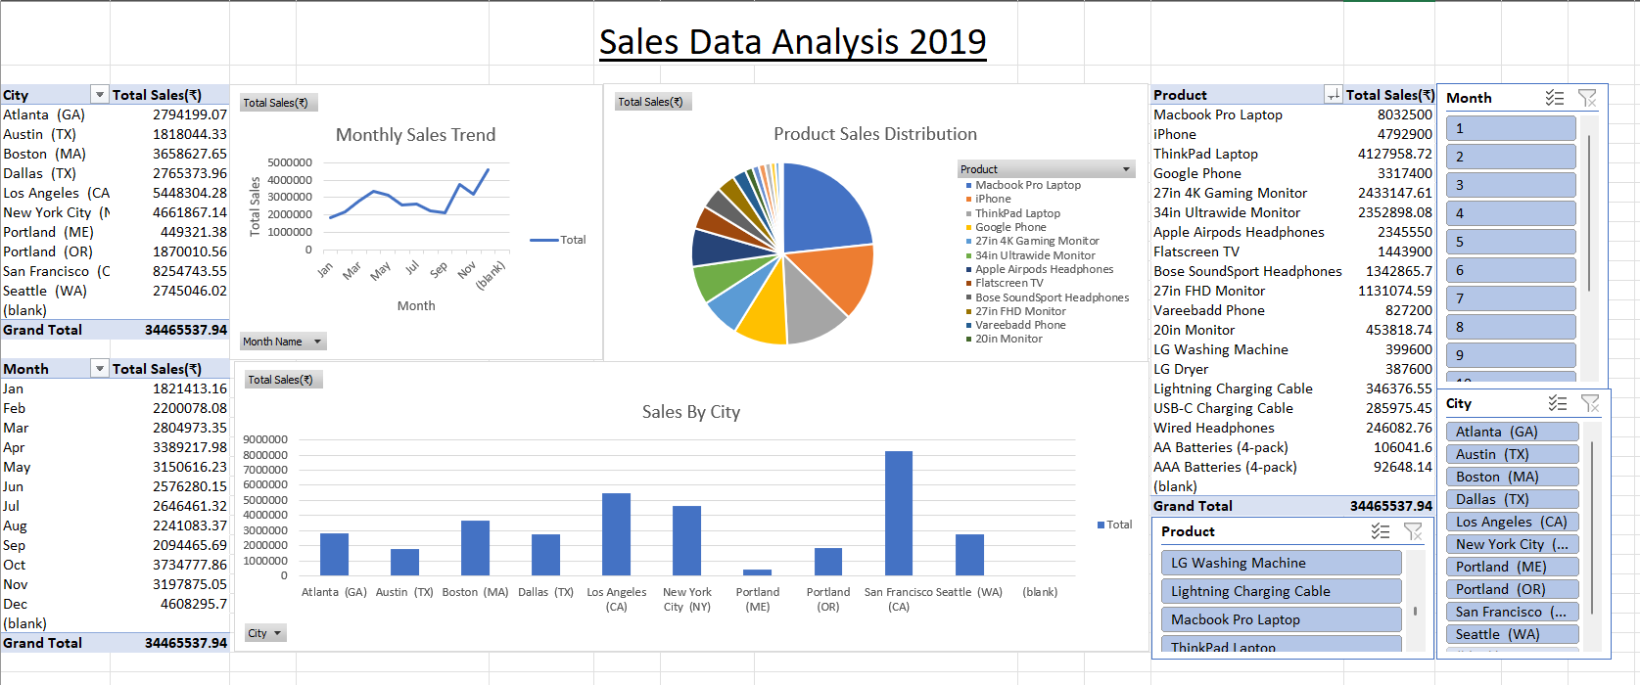
Fig 1. Excel Dashboard
- Power BI Dashboard:
  - KPI Cards for Total Sales, Orders, Quantity
  - Line Chart: Total Sales by Month
  - Donut Chart: Total Sales by Product
  - Bar Chart: Total Sales by City
  - Line Area Chart: Total Sales by Hour
  - Column Chart: Top 5 Products by Sales
  - Interactive filters for City, Product, and Month
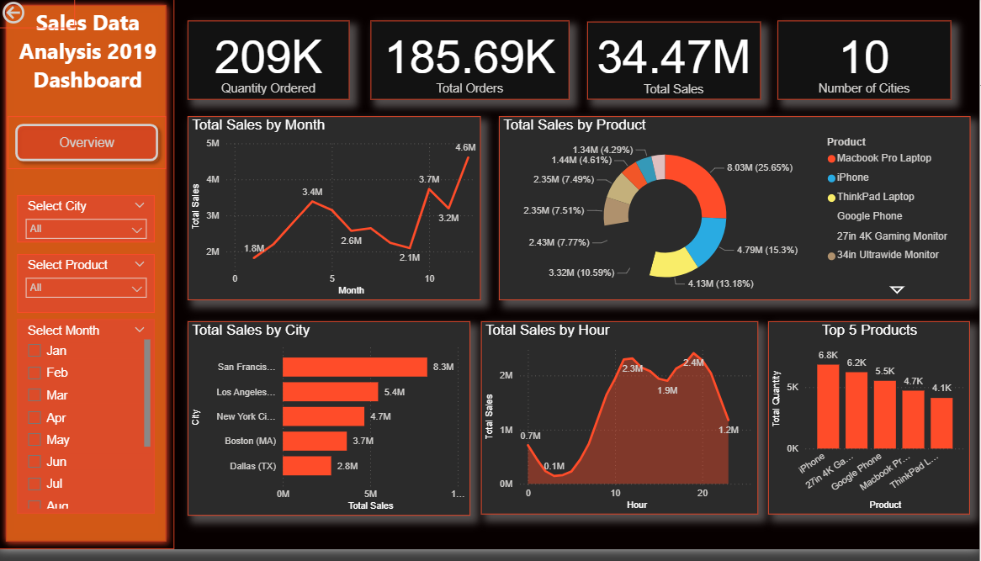
Fig 2. Power BI Dashboard

6. Limitations
- Data covers only 2019, limiting year-over-year comparison.
- No profit or cost data available to evaluate profit margins.
- Customer demographic information not included, which restricts deeper segmentation.
- Some smaller cities have incomplete or low-frequency data points.

7. Recommendations
- Extend dataset to multiple years for trend forecasting.
- Incorporate Profit, Discount, and Cost columns to analyze profitability.
- Introduce customer demographic data (age, region, purchase channel) for targeted marketing.
- Use Power BI’s forecasting tools to project future monthly sales.
- Focus inventory and marketing campaigns on high-performing regions and products before peak seasons.

